Logic Gate: OR

Epoch 1/10: Weights = [2. 2. 2.], Errors = 4

Epoch 2/10: Weights = [2. 2. 2.], Errors = 0

No errors, training converged.

Weights: [2. 2. 2.]

Predictions: [1, 1, 1, -1]

AUC-ROC Score: 1.00

Logic Gate: XOR

Epoch 1/10: Weights = [0. 0. 0.], Errors = 4

Epoch 2/10: Weights = [0. 0. 0.], Errors = 4

Epoch 3/10: Weights = [0. 0. 0.], Errors = 4

Epoch 4/10: Weights = [0. 0. 0.], Errors = 4

Epoch 5/10: Weights = [0. 0. 0.], Errors = 4

Epoch 6/10: Weights = [0. 0. 0.], Errors = 4

Epoch 7/10: Weights = [0. 0. 0.], Errors = 4

Epoch 8/10: Weights = [0. 0. 0.], Errors = 4

Epoch 9/10: Weights = [0. 0. 0.], Errors = 4

Epoch 10/10: Weights = [0. 0. 0.], Errors = 4

Weights: [0. 0. 0.]

Predictions: [0, 0, 0, 0]

AUC-ROC Score: 0.50

Logic Gate: XNOR

Epoch 1/10: Weights = [0. 0. 0.], Errors = 4

Epoch 2/10: Weights = [0. 0. 0.], Errors = 4

Epoch 3/10: Weights = [0. 0. 0.], Errors = 4

Epoch 4/10: Weights = [0. 0. 0.], Errors = 4

Epoch 5/10: Weights = [0. 0. 0.], Errors = 4

Epoch 6/10: Weights = [0. 0. 0.], Errors = 4

Epoch 7/10: Weights = [0. 0. 0.], Errors = 4

Epoch 8/10: Weights = [0. 0. 0.], Errors = 4

Epoch 9/10: Weights = [0. 0. 0.], Errors = 4

Epoch 10/10: Weights = [0. 0. 0.], Errors = 4

Weights: [0. 0. 0.]

Predictions: [0, 0, 0, 0]

AUC-ROC Score: 0.50

Logic Gate: NOR

Epoch 1/10: Weights = [-2. -2. -2.], Errors = 4

Epoch 2/10: Weights = [-2. -2. -2.], Errors = 0

No errors, training converged.

Weights: [-2. -2. -2.]

Predictions: [-1, -1, -1, 1]

AUC-ROC Score: 1.00

Logic Gate: NAND

Epoch 1/10: Weights = [2. 2. 2.], Errors = 4

Epoch 2/10: Weights = [2. 2. 2.], Errors = 0

No errors, training converged.

Weights: [2. 2. 2.]

Predictions: [1, 1, 1, -1]

AUC-ROC Score: 1.00

Logic Gate: AND

Epoch 1/10: Weights = [-1. 1. 1.], Errors = 3

Epoch 2/10: Weights = [-2. 2. 2.], Errors = 3

Epoch 3/10: Weights = [-2. 2. 2.], Errors = 0

No errors, training converged.

Weights: [-2. 2. 2.]

Predictions: [1, -1, -1, -1]

AUC-ROC Score: 1.00

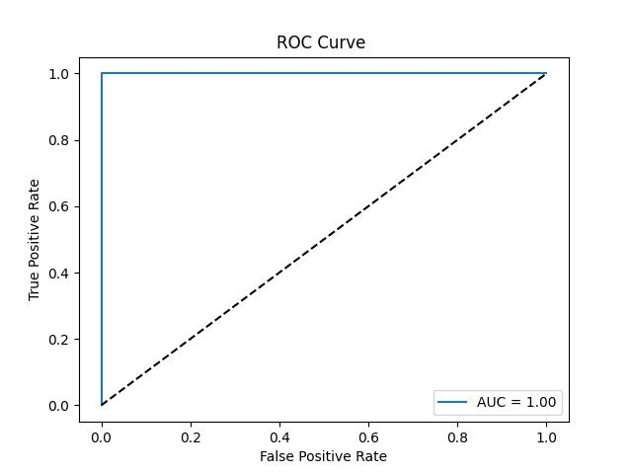

OR GATE

